**Lesson 04 Demo 02**

**Generating UI Design Using Uizard**

**Objective:** To generate the UI design for a web application for GroceryGo, a grocery company, using Uizard to enhance user experience and streamline online shopping

**Tools required:** Uizard

**Prerequisites:** NA

Steps to be followed:

1. Use Uizard AI to generate a user interface (UI) design for a web application

**Note:** Generative AI tool used in this exercise can produce varied outputs even when presented with similar prompts. Thus, you may get different outputs for the same prompt.

**In Free tier option you can create max two project and each project can contain max 2 to 3 web pages. So, if you need to utilize all features of Uizard you need to upgrade to pro version depending upon your requirements.**

**Step 1: Use Uizard AI to generate a user interface (UI) design for a web**

**Application**

**Target Audience:** Primarily aimed at non-designers and people who want to quickly generate designs without needing deep design skills.

* 1. Navigate to the Uizard website, create an account, and log in

<https://uizard.io/>

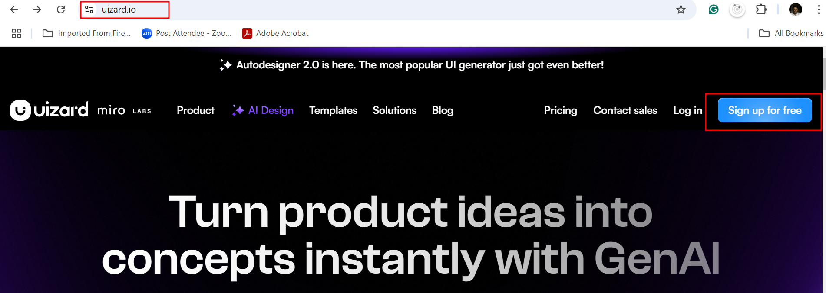

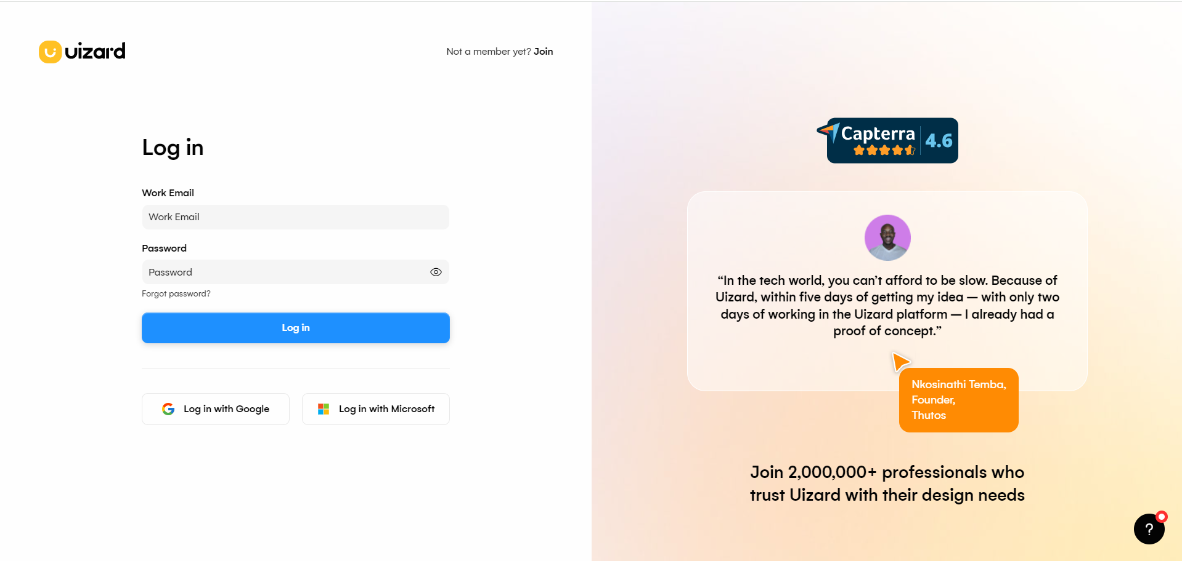

* 1. Select the terms and conditions and click on **Accept**.

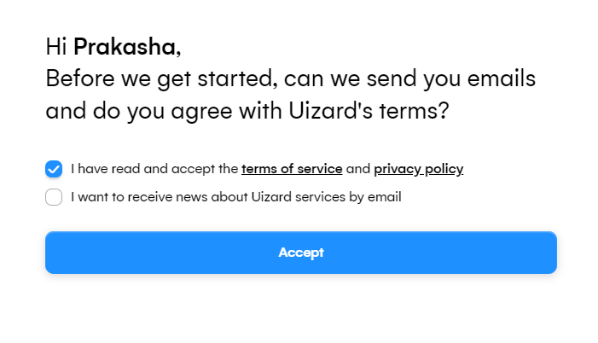

* 1. Answer the given questions

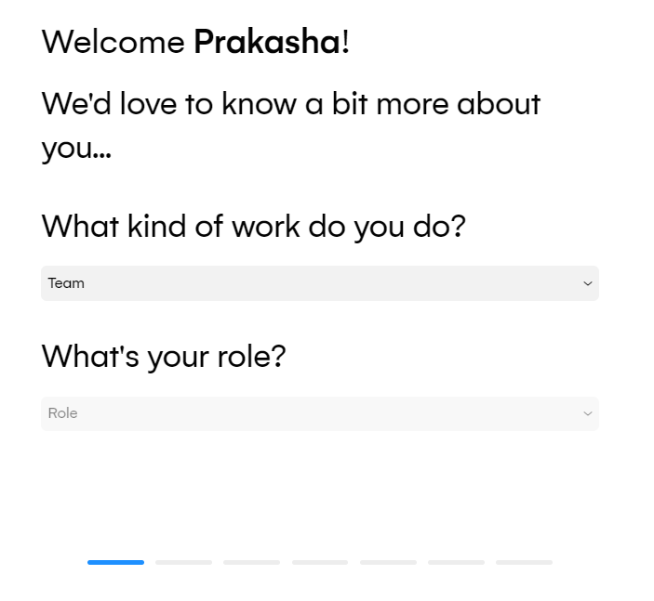

* 1. Select the appropriate interface based on usage. In this case, choose **Design a new   
      mobile app or website project**

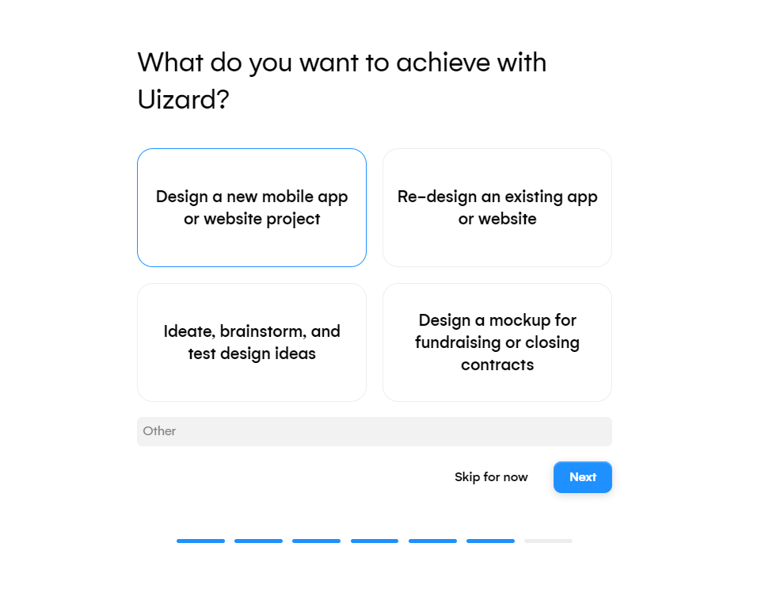

The following page appears once all the processes are completed:

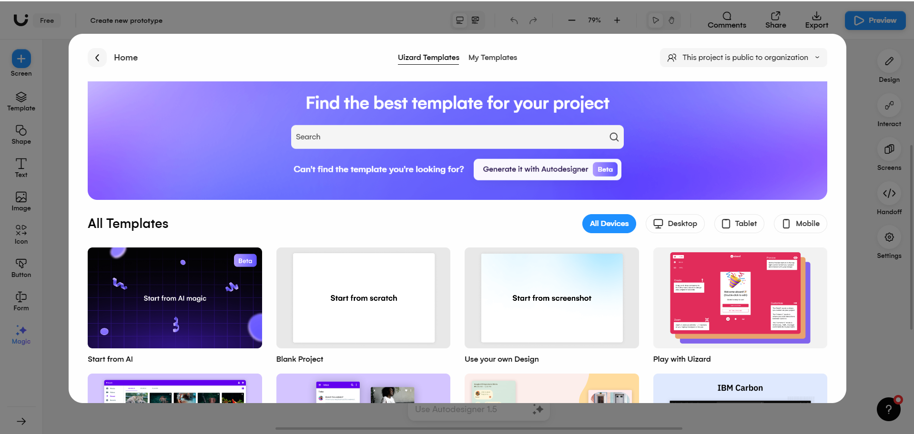

* 1. Click on **Generate it with Autodesigner** to generate the web application



The page appears as follows:

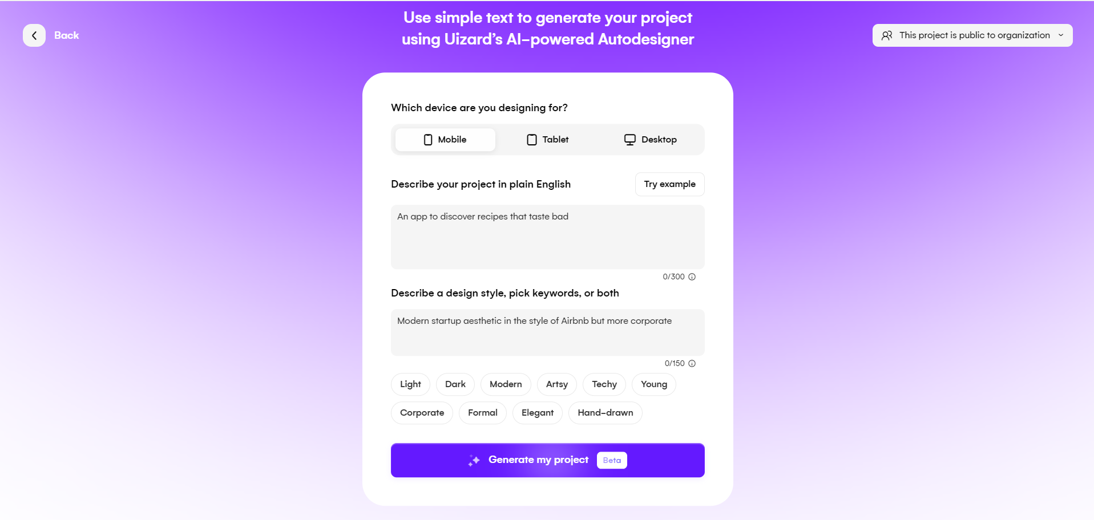

* 1. Select **Desktop** as the device and choose the specified options for designing the web application. In this case, select **Modern** and **Elegant**. Then, provide the following prompt and click on **Generate my project**:

**A grocery app named GroceryGo contains a home page, user profile, cart, and wishlist. All pages should be connected with each other.**

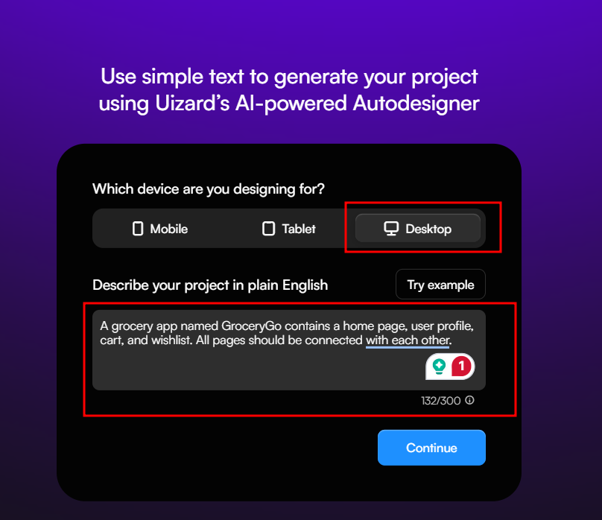

1.7 Here it will ask sub option you need to select.

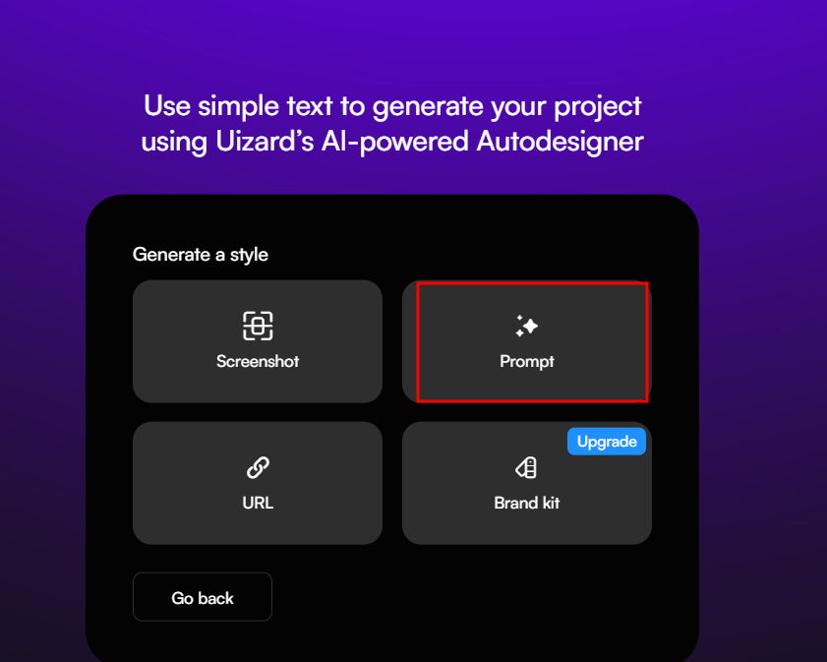

**Screenshot:**

**What it is**: You can upload a screenshot of a design or a webpage you like. Uizard's AI will analyze the screenshot and try to replicate or draw inspiration from it for your project.

**Prompt:**

**What it is**: This is where you describe what you want the AI to create in text. You provide a detailed description, and Uizard uses that to generate a design.

**URL:**

**What it is**: You provide the URL of an existing website. Uizard's AI will analyze the website's layout and design, then generate something similar for you.

1.8 Here we select prompt option as of now.

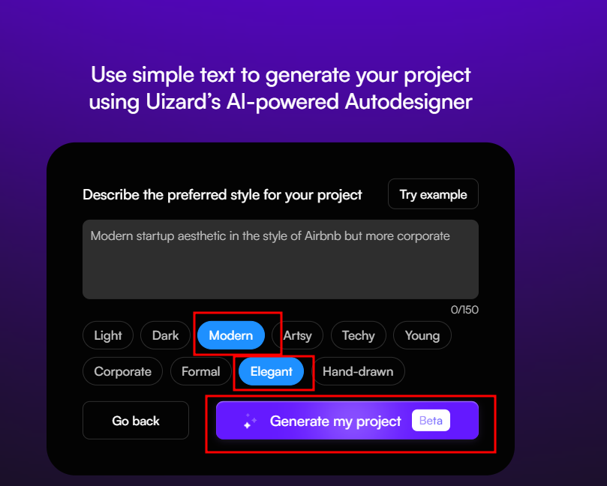

Here select extra effect for all web page as Modern and Elegant. You can select any other option depending upon our requirements. Then click generate my project options.

1.9 You will see the following interface:

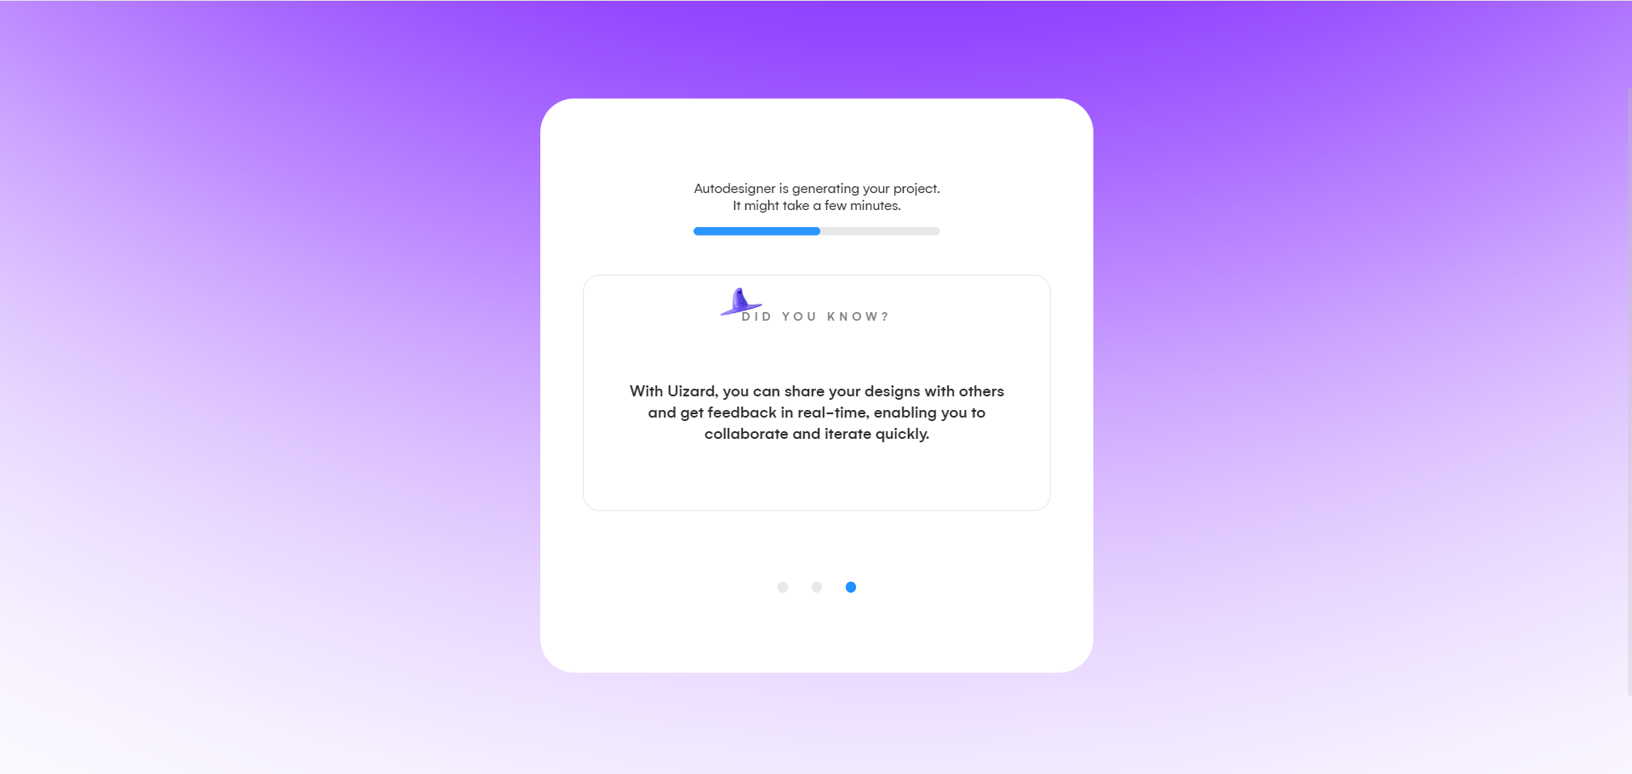

1.10 The web application is generated, and it appears as follows:

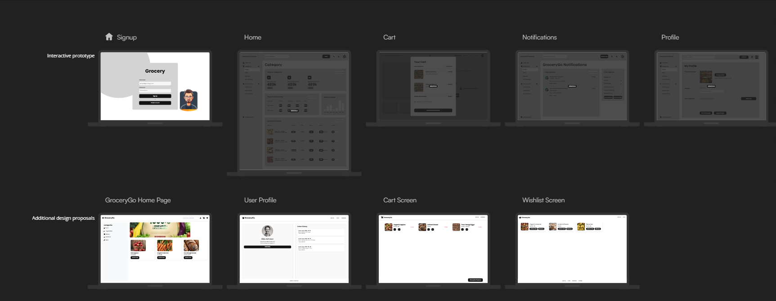

* 1. Click on the **Preview** button at the top right to view the generated UI application

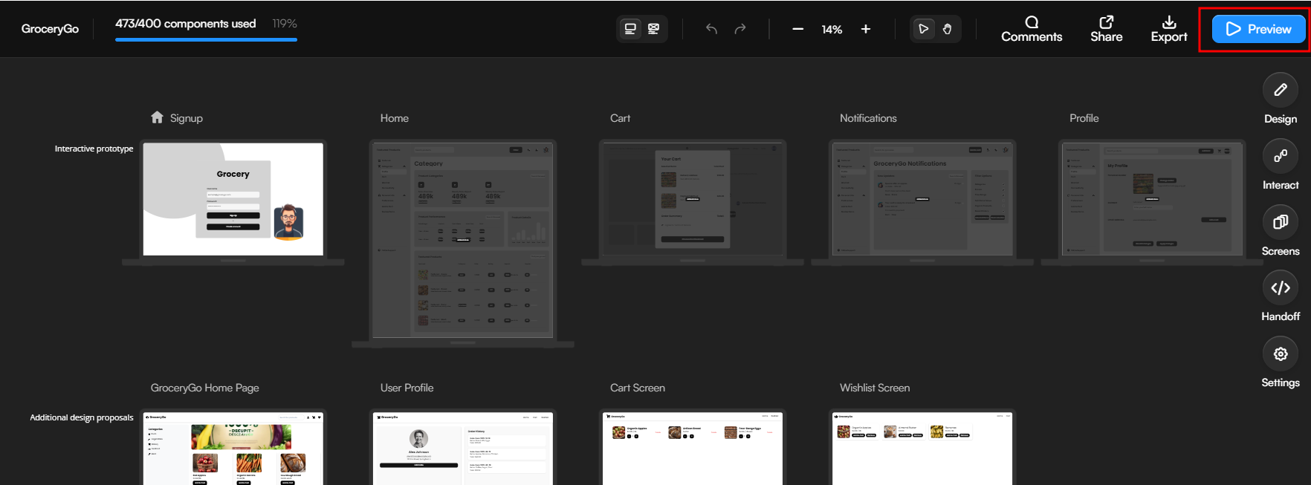

1.12 You can see the output as Preview option

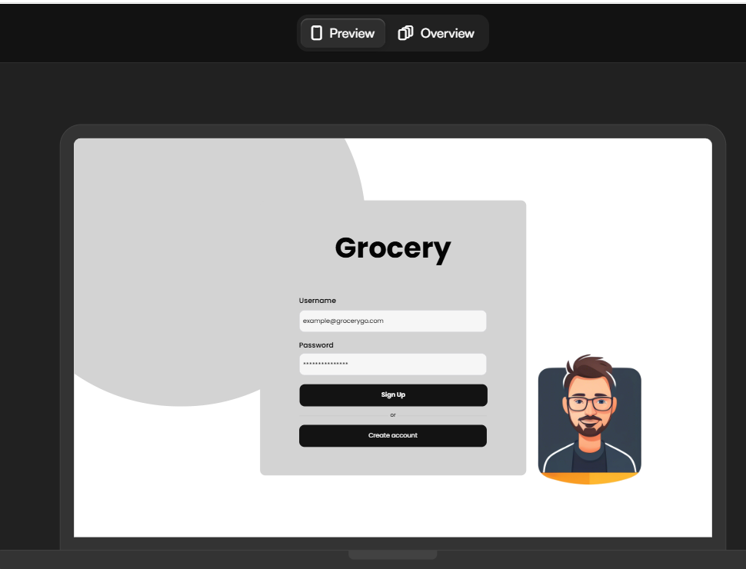

1.13 Here you can click on highlighted option to navigate another page.

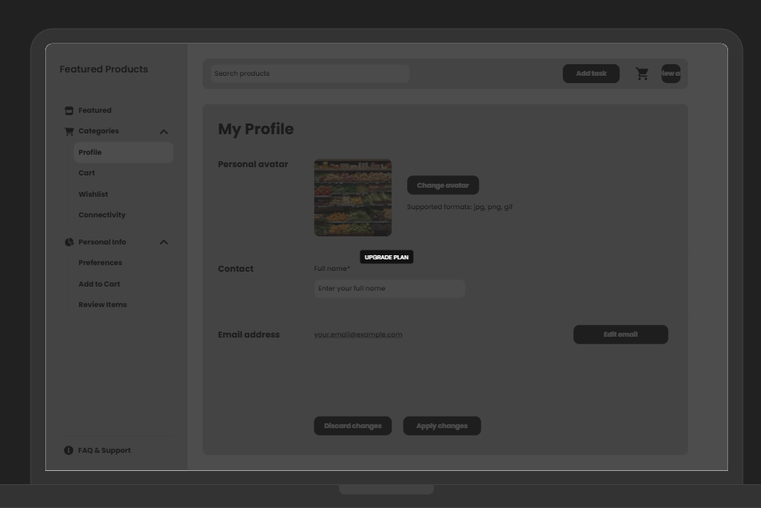

1.14 Click on overview option to see all pages.

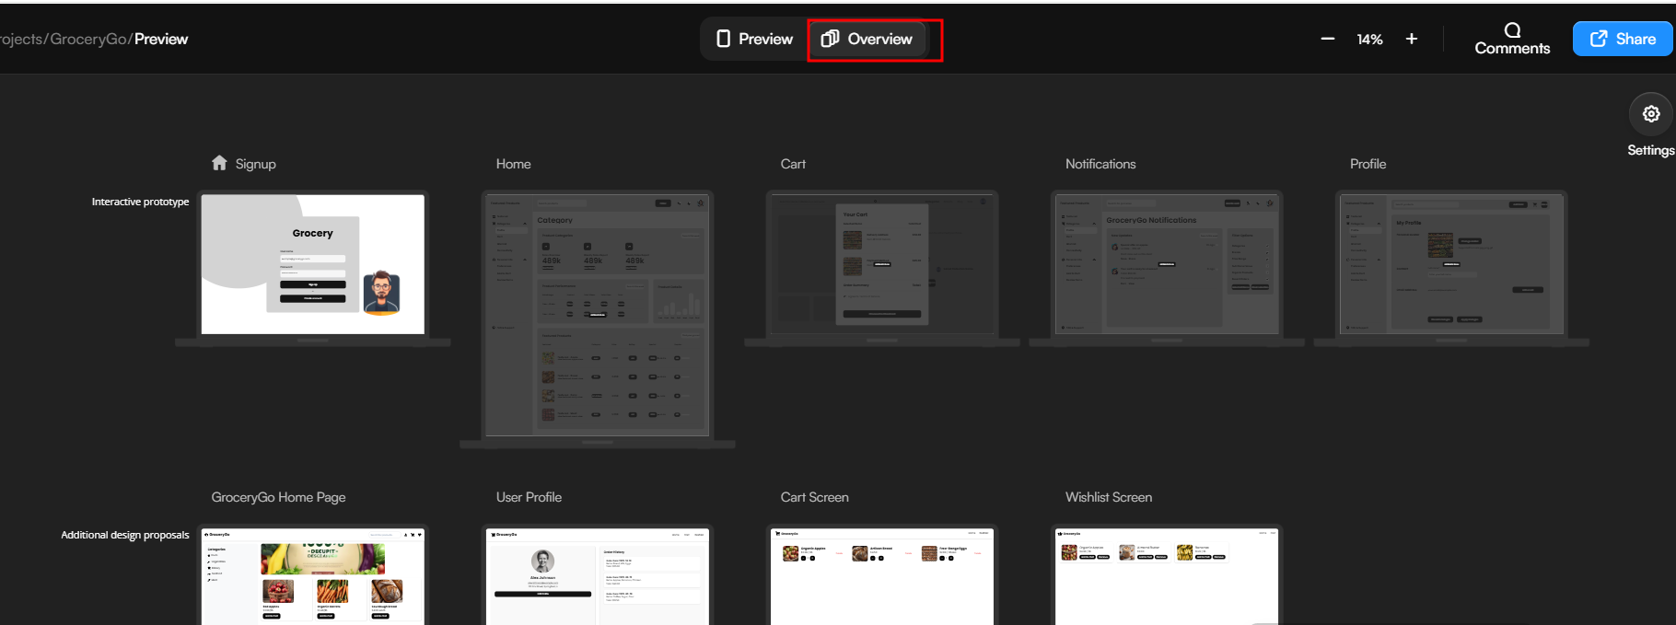

1.15 Navigate to the UI generated page, select the generated pages, click on **Export** at the top right, and then click on **Export** to export the project as a zip file

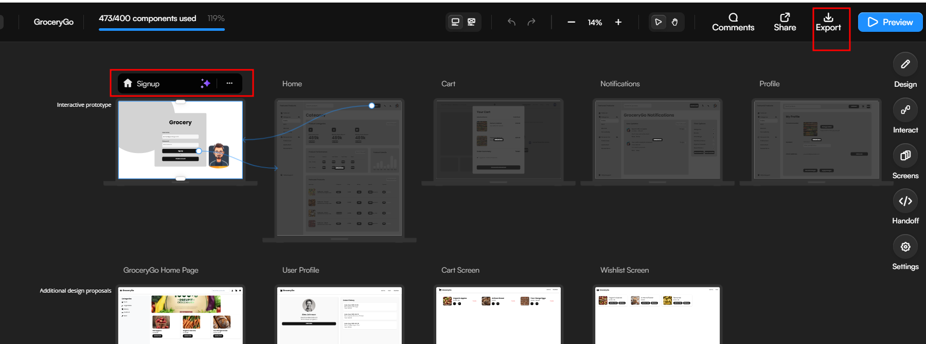

1.16 So in free tier you can export individual page in image format but depending upon the requirement you can generate the complete code with html/css or any other framework/library.

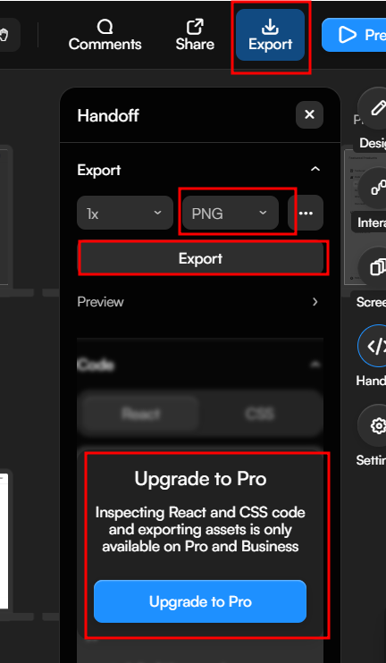

1.17 You can view the generate page.

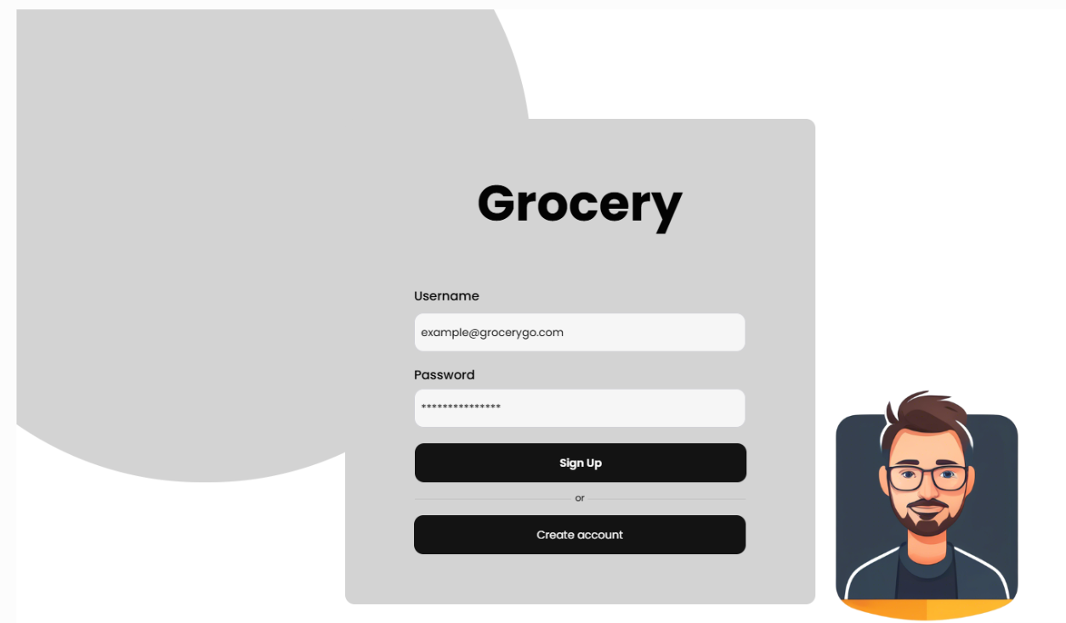

1.18 same way you can generate image for all the pages.